Task 1

The Value Iteration Agent class holds the iterate method that has a loop that run 50 times now. This allows the J-unit test to run through 50 games and present the test amount of time the agent has won, lost and drew within the tic-tac-toe game. For an aggressive and random agent, the results show 50 wins, 0 loses and 0 draws. Whereas the defensive agent shows 46 wins and 4 draws. The result was expected from coding the value iteration and policy extraction methods for test to pass and generate the wanted results for the agent to have no loses within the J-unit test.

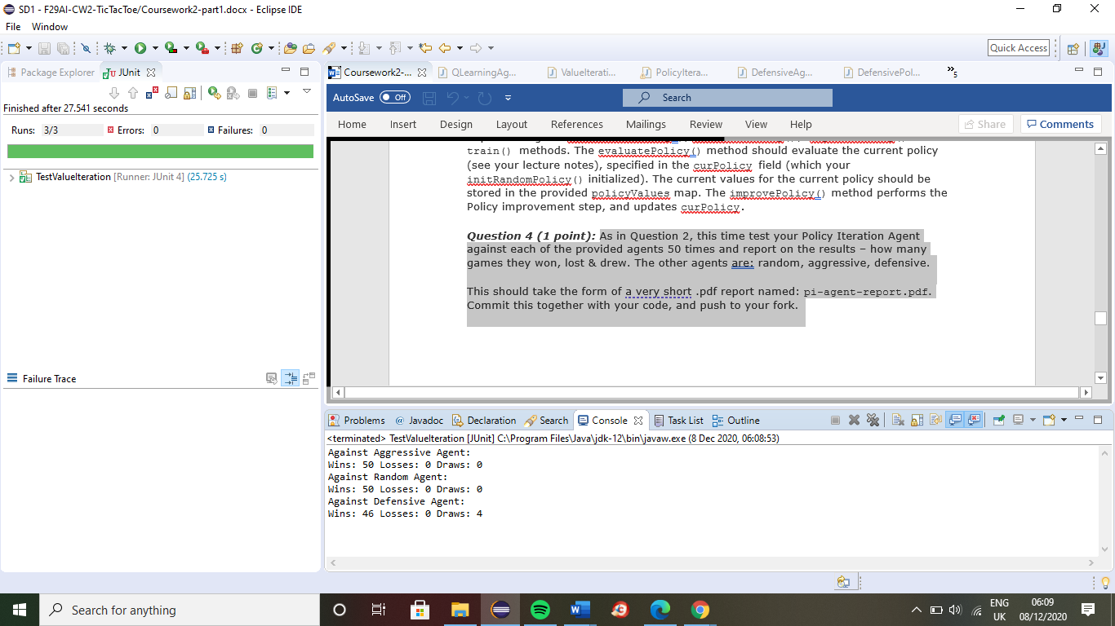

Task 2

The J-unit test allows the agent to go through the agent 50 times and represents the successfully presents the result for each type of agent. The console successfully shows the results for the random, aggressive, and defensive agent with no losses displayed. Even though, the defense agent does not show all the wins with 7 draws, it is a great sign that the agents never lose a game. Therefore, the policy iteration agent is structured correctly to generate the intended output within the J-unit test

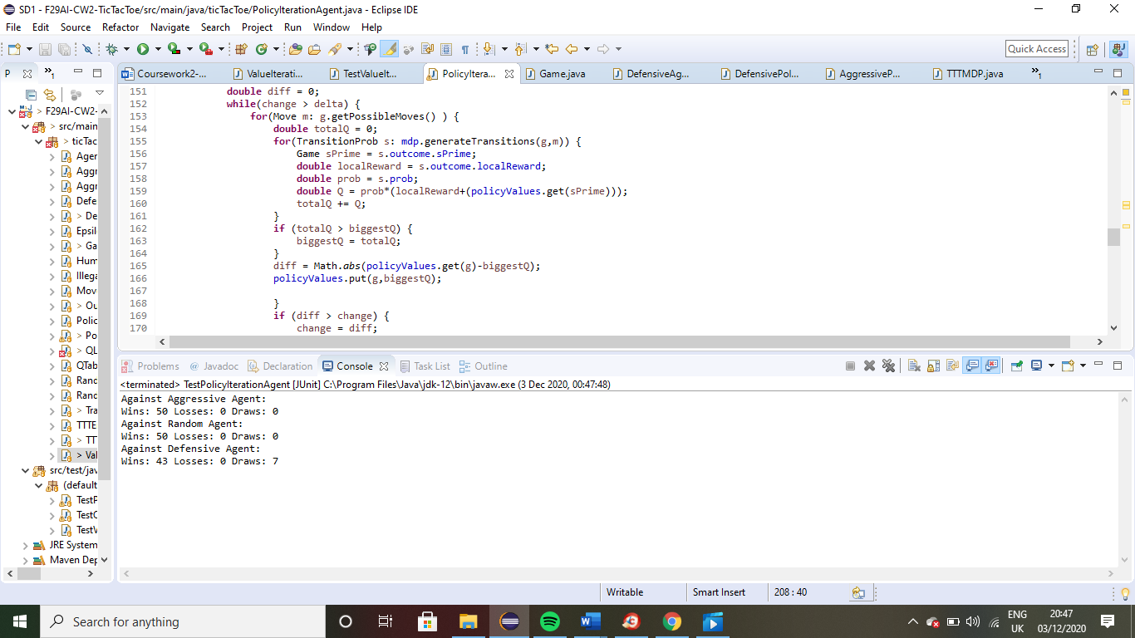

Task 3

The J-unit test for the QLearning Agent involves the use of a Q table, this goes through the agent 50 again. It is evident through the results that the tests are running without errors, but sadly has failures. This is because of the methods within QLearning Agent not being coded properly to result in a test having zero failures within the three agents. Therefore, it is important to keep on refining the coding for the methods to eventually have the agents always succeed for every game

